Data Structures & Algorithms (CSC-214) Semester: Spring 2025
Lab 12: Binary Search Tree Date: 16th May 2025

Part 1: Binary Search Tree
Use the given binary search tree code and perform the following tasks:
- Create a tree in main
- Make a series of insertions
- Display inorder, preorder and post order
- Add a function which finds the max value in the tree and returns in, test your function
- Add a function which finds the min value in the tree and returns it, test your function
- Add a function that sums all the values of the nodes in the tree and returns it
- Use the code given below to see the tree structure (the code will give a horizontal version), and confirm that it is being built correctly
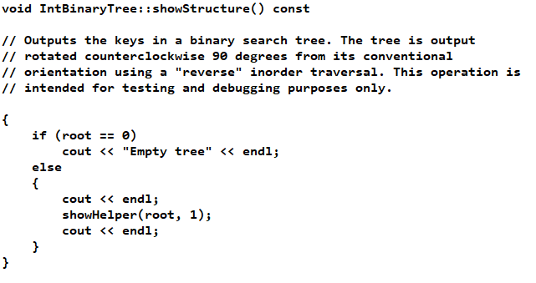

Part 2: Expression Tree – Construction, Traversal & Evaluation
Q1: Write a C++ program that:
- Manually builds an expression tree for the arithmetic expression ((5+3)*(8-2)).
- Performs and displays:
  - The prefix traversal (pre-order),
  - The postfix traversal (post-order),
  - The evaluated result of the expression tree.
Implementation details:
- You do not need to take the expression as input.
- Directly create the tree using TreeNode objects.
- Use only single-digit numbers and operators +, -, *, /.
Example Expression Tree:
The expression ((5+3)*(8-2)) can be represented by the following tree:
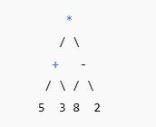
Sample output:
Prefix: *+53-82
Postfix: 53+82-*
Evaluation Result: 48
Q2: Construct a tree for the given inorder and postorder traversals (draw on paper)
- Inorder: DGBAHEICF
- Postorder: GDBHIEFCA
Q3: Given a binary tree, write a function to return the maximum value at each level using breadth first traversal. You may use the code provided in class.
Q4: Given a tree structure as input, write a function to count:
- Total number of nodes
- Total number of leaf nodes
- Total number of internal nodes
You may use the code given in class.

